

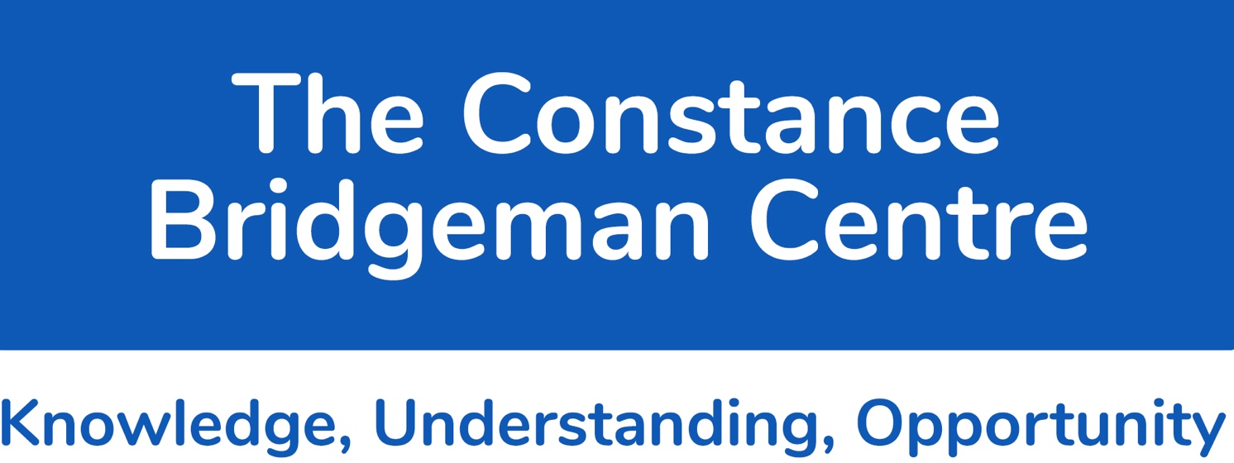

**Marking and Feedback policy 2023**

Marking is a central part of a teacher’s role and can be integral to progress and attainment. Written responses offer a key way of providing feedback to pupils and helping teachers assess their students’ understanding. However, the 2016 report of the Independent Teacher Workload Review Group noted that written marking had become disproportionately valued by schools, unnecessarily burdensome for teachers and that quantity of feedback has too often become confused with the quality. The group noted that there is no ‘one size fits all’ way to mark, instead recommending that all marking should be driven by professional judgement and be “meaningful, manageable and motivating”. For all these reasons, there is a clear need for high-quality evidence to inform schools’ decision-making about marking.

Individual departments should use the principles outlined in this marking and feedback policy to create their own subject-specific, tailored departmental assessment policies. This is really an ‘internalising’ of the school departmental policy, making it fit the demands of your curriculum, in the knowledge that curriculum and subject leaders are responsible for setting and monitoring the quality and frequency of feedback from teachers working within their team.

***Please consider the following definitions and principles:***

***Marking = the routine activity of reading, checking, monitoring, (when appropriate) correcting, and (where appropriate) giving a mark to students’ written work.***

***Feedback = providing more detailed guidance to the learner in order to help them to improve their knowledge, understanding and skills.***

While it is important to note that written marking is only one form of feedback, marking offers an opportunity to provide pupils with the clear and specific information that the wider evidence base on feedback suggests is most likely to lead to pupil progress.

**Regularity of Marking and Feedback**

Marking students’ books is part of our professional duty. Routinely reading, checking and monitoring students’ books connects us to their learning and helps to ensure that they care about the work they produce. It shows students that we value their work and provides us with crucial on-going information about how well they are learning. It also enables us to monitor the completion of class-based tasks.

This kind of routine light marking should be regular, timely and manageable. Frequency will vary from subject to subject, but as a general rule books should be taken in and checked approximately every two to four weeks, or twice per half-term.

|  |  |  |
| --- | --- | --- |
|  | Core Subjects | Non-Core Subjects |
| Marking/Feedback | Every two to three weeks | Every three to four weeks |
| Tracking Sheet | Each Term | Each Term |

**Features of ‘Marking’:**

* Summative
* Assessment of Learning
* Direct thinking
* “You should…”

**Feedback**

Feedback is specific information given to the learner about their performance relative to learning goals. It should aim to (and be capable of) producing improvement in students’ learning.

Providing effective feedback is challenging. Research suggests that it should:

* •  be specific, accurate and clear (e.g. “It was good because you...” rather than just “correct”)
* •  compare what a learner is doing right now with what they have done wrong before (e.g. “I can see you were focused on improving X as it is much better than last time’s Y...”)
* •  encourage and support further effort and be given sparingly so that it is meaningful
* •  provide specific guidance on how to improve and not just tell students when they are wrong
* •  be supported with effective professional development for teachers.

Given the increasing focus on quality of written communication (QWC) in all examinations with a written component, when and where appropriate, teachers should provide feedback on literacy; for example, addressing misspelling of key terms, lower case proper nouns and other punctuation errors. If teachers do not correct spelling, punctuation and grammar (SPaG) in books we give implicit authority to students to continue making the same mistakes.

**External appearance of the book/portfolio/folder:**

All books must have the following clearly stated:

* Student name
* Subject
* Teacher
* Class/Year group

There should be no other form of writing or drawing on the cover of the book.

**Tracking Sheet:**

At least once every term Tracking sheet should be used for marking to provide students with more details on their progress and achievements.

Here is a suggested Tracking sheet, which can be used for this:

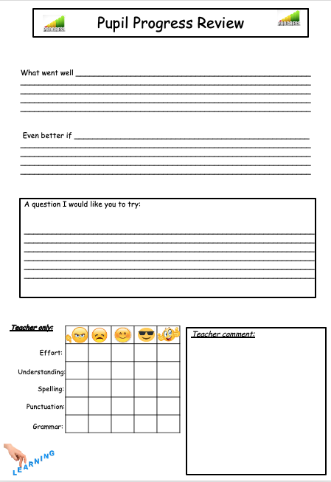

This will provide learners with details on what they were able to achieve and what they did well, as well as identify areas for development.

There is also an area for general comment on observation and personal/social feedback.

Teacher mark box, further provides cocurricular marking opportunity and a link to literacy, spelling and effort.

Here are some examples of wording you could use:

|  |  |
| --- | --- |
| **What Went Well** | **Even Better If** |
| **You have understood . . .** | **Next time you could include . . .** |
| **The best part of your work was . . .** | **Next time you could change . . .** |
| **You showed all the working out** | **You attempted the extension work . . .** |
| **You used the appropriate equipment for this work** | **You use the appropriate equipment (ruler/pencil)** |
| **You presented all your graphs/charts neatly** | **You set your work out clearly so it can be read** |
| **Your work was well set out and easy to read** | **You showed working out so your workings could be followed and understood** |
| **You showed good understanding of the topic** | **You revise this work so you’ll know how to do it in a week/month/years’ time** |
| **It is clear you understand this topic** | **You check your spelling of the key words** |

For regular marking the following format can be used:

